SDLC Models Documentation

1. Agile Model
The Agile Model is an iterative and incremental approach to software development that focuses on flexibility, collaboration, and customer feedback. Instead of delivering the entire product at once, development happens in small cycles called sprints.
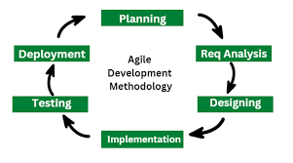

Key Features:
- Iterative development
- Continuous feedback
- Allows changes anytime
- Cross-functional teams

Advantages:
- Faster delivery of features
- High customer satisfaction
- Better risk management
- Improved quality through continuous testing

Limitations:
- Requires skilled team members
- Documentation may be less detailed
- Not ideal for very large projects without clear direction

2. Waterfall Model
The Waterfall Model is a linear SDLC approach where each phase must be completed before moving to the next. It is simple and structured, making it suitable for small projects with well-defined requirements.
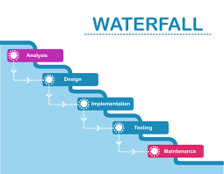

Phases:
- Requirement Gathering
- System Design
- Implementation
- Testing
- Deployment
- Maintenance

Advantages:
- Easy to understand and manage
- Clear documentation
- Works well for stable, predictable projects

Limitations:
- No flexibility for changes
- Problems discovered late in testing
- Not suitable for complex or evolving projects

3. V-Model
The V-Model, also known as the Verification and Validation model, is an extension of the Waterfall approach. Each development phase has a corresponding testing phase, forming a V structure.
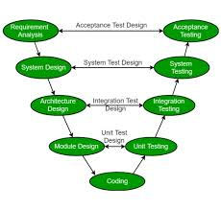

Structure:
- Left side: Verification (requirements, design)
- Bottom: Implementation
- Right side: Validation (testing levels)

Advantages:
- Testing is planned early
- High-quality output
- Easy defect tracking

Limitations:
- Rigid and inflexible
- Costly for major changes
- Not suitable for iterative or dynamic projects

4. Spiral Model
The Spiral Model is a risk‑driven SDLC model combining iterative development with systematic risk analysis. Each cycle (spiral) includes planning, risk evaluation, engineering, and review.
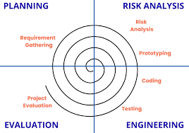

Phases per Spiral:
- Objective setting
- Risk identification and analysis
- Development and testing
- Evaluation and planning next cycle

Advantages:
- Best for high‑risk, large projects
- Strong risk management
- Early detection of issues

Limitations:
- Expensive compared to other models
- Requires skilled risk evaluators
- Can become complex for small projects

